Plotting with pandas and seaborn
Now that we have a basic sense of how to load and handle data in a pandas DataFrame object, let's get started with making some simple plots from data. While there are several plotting libraries in Python (including matplotlib, plotly, and seaborn), in this chapter, we will mainly explore the pandas and seaborn libraries, which are extremely useful, popular, and easy to use.

Creating Simple Plots to Visualize a Distribution of Variables
matplotlib is a plotting library available in most Python distributions and is the foundation for several plotting packages, including the built-in plotting functionality of pandas and seaborn. matplotlib enables control of every single aspect of a figure and is known to be verbose. Both seaborn and pandas visualization functions are built on top of matplotlib. The built-in plotting tool of pandas .is a useful exploratory tool to generate figures that are not ready for primetime but useful to understand the dataset you are working with. seaborn, on the other hand, has APIs to draw a wide variety of aesthetically pleasing plots.
To illustrate certain key concepts and explore the diamonds dataset, we will start with two simple visualizations—histograms and bar plots.
Histograms
A histogram of a feature is a plot with the range of the feature on the x-axis and the count of data points with the feature in the corresponding range on the y-axis.

Plotting and Analysing a Histogram
We will create a histogram of the frequency of diamonds in the dataset with their respective carat specifications on the x-axis:
- Import the necessary modules:
import matplotlib.pyplot as plt
import seaborn as sns
import pandas as pd
- Import the diamonds dataset from seaborn:
- diamonds_df=pd.read_csv("diamonds.csv")
- Plot a histogram using the diamonds dataset where x axis = carat:
diamonds_df.hist(column='carat')
The output is as follows:
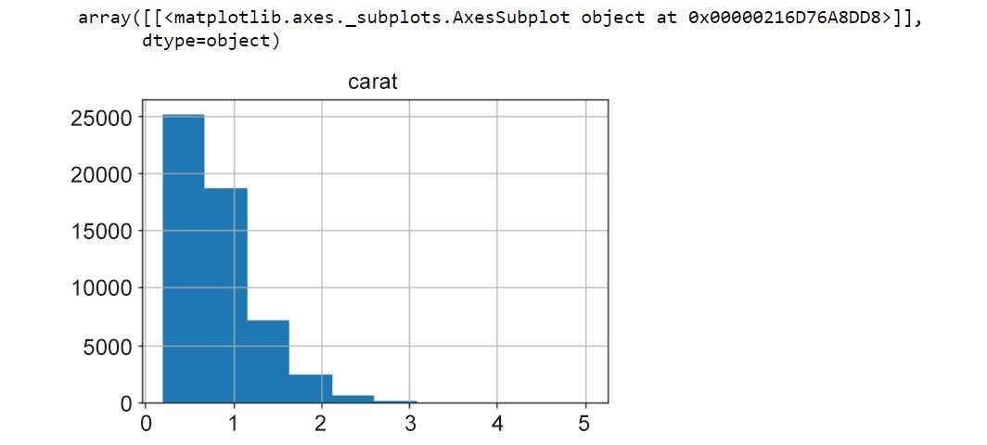
Figure 1.14: Histogram plot
The y axis in this plot denotes the number of diamonds in the dataset with the carat specification on the x-axis.
The hist function has a parameter called bins, which literally refers to the number of equally sized bins into which the data points are divided. By default, the bins parameter is set to 10 in pandas. We can change this to a different number, if we wish.
- Change the bins parameter to 50:
diamonds_df.hist(column='carat', bins=50)
The output is as follows:
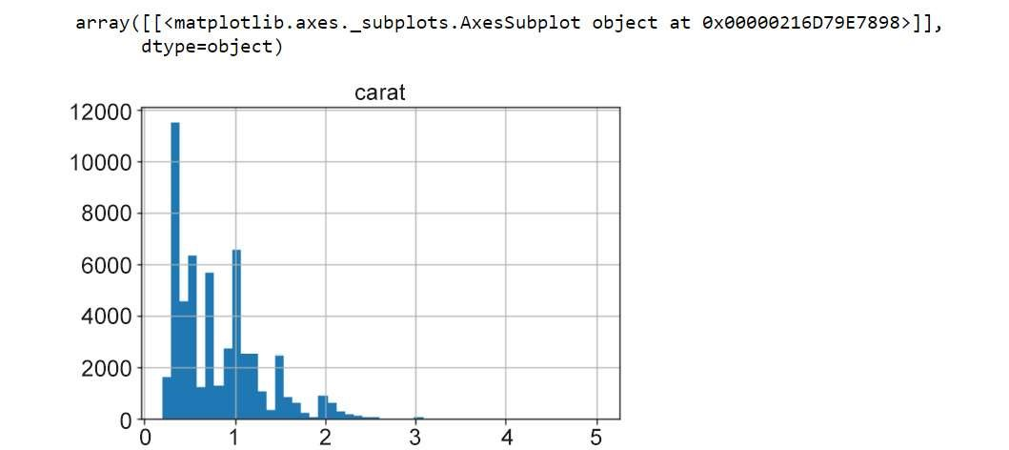
Figure 1.15: Histogram with bins = 50
This is a histogram with 50 bins. Notice how we can see a more fine-grained distribution as we increase the number of bins. It is helpful to test with multiple bin sizes to know the exact distribution of the feature. The range of bin sizes varies from 1 (where all values are in the same bin) to the number of values (where each value of the feature is in one bin).
- Now, let's look at the same function using seaborn:
sns.displot(diamonds_df.carat)
The output is as follows:
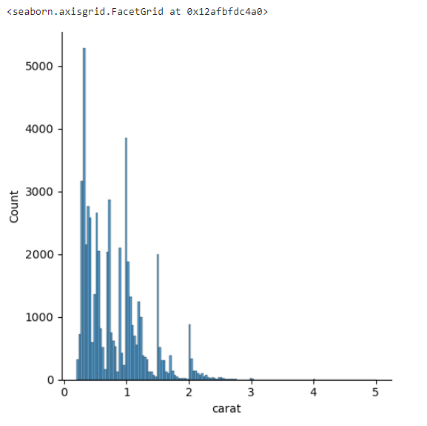
Figure 1.16: Histogram plot using seaborn
There are two noticeable differences between the pandas hist function and seaborn displot:
  - pandas sets the bins parameter to a default of 10, but seaborn infers an appropriate bin size based on the statistical distribution of the dataset.
  - By default, the distplot function also includes a smoothed curve over the histogram, called a kernel density estimation.
The kernel density estimation (KDE) is a non-parametric way to estimate the probability density function of a random variable. Usually, a KDE doesn't tell us anything more than what we can infer from the histogram itself. However, it is helpful when comparing multiple histograms on the same plot. If we want to add the KDE, we can use the kde=True parameter.
- Change kde=True to add the KDE:
sns.displot(diamonds_df.carat, kde=True)

The output is as follows:
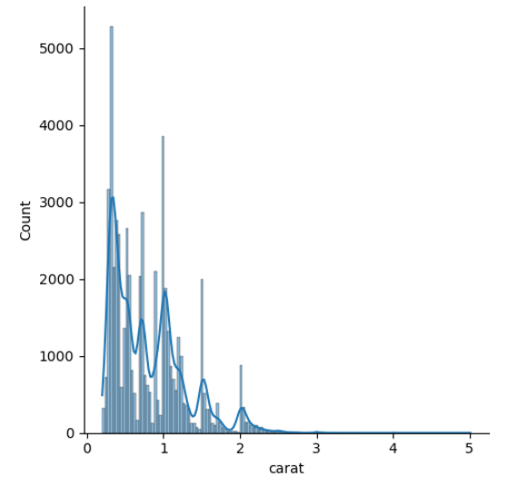

Figure 1.17: Histogram plot with KDE = false
Also note that the bins parameter seemed to render a more detailed plot when the bin size was increased from 10 to 50. Now, let's try to increase it to 100.
- Increase the bins size to 100:
sns.displot(diamonds_df.carat, bins=100)
The output is as follows:
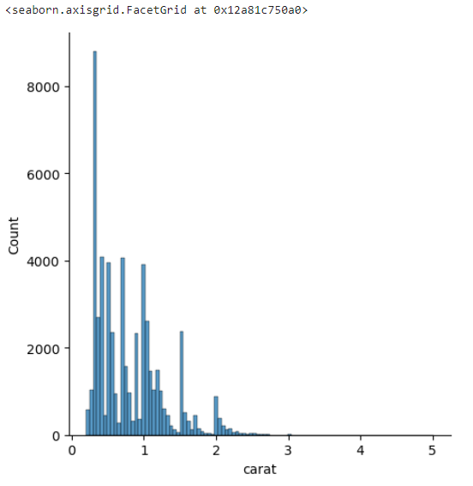
Figure 1.18: Histogram plot with increased bin size
The histogram with 100 bins shows a better visualization of the distribution of the variable—we see there are several peaks at specific carat values. Another observation is that most carat values are concentrated toward lower values and the tail is on the right—in other words, it is right-skewed.
A log transformation helps in identifying more trends. For instance, in the following graph, the x-axis shows log-transformed values of the price variable, and we see that there are two peaks indicating two kinds of diamonds—one with a high price and another with a low price.
- Use a log transformation on the histogram:
import numpy as np sns.displot(np.log(diamonds_df.price)
The output is as follows:
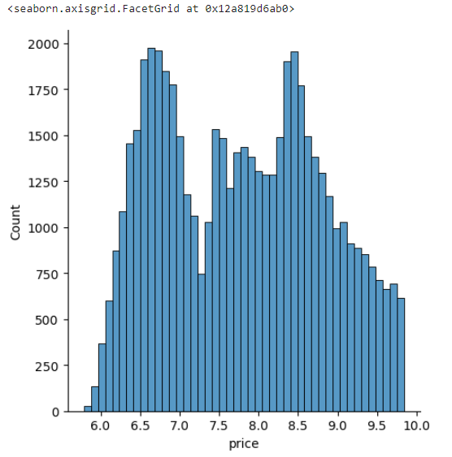
Figure 1.19: Histogram using a log transformation
That's pretty neat. Looking at the histogram, even a naive viewer immediately gets a picture of the distribution of the feature. Specifically, three observations are important in a histogram:
- Which feature values are more frequent in the dataset (in this case, there is a peak at around 6.8 and another peak between 8.5 and 9—note that log(price) = values, in this case,
- How many peaks exist in the data (the peaks need to be further inspected for possible causes in the context of the data)
- Whether there are any outliers in the data

Bar Plots
In their simplest form, bar plots display counts of categorical variables. More broadly, bar plots are used to depict the relationship between a categorical variable and a numerical variable. Histograms, meanwhile, are plots that show the statistical distribution of a continuous numerical feature.
First, we shall present the counts of diamonds of each cut quality that exist in the data. Second, we shall look at the price associated with the different types of cut quality (Ideal, Good, Premium, and so on) in the dataset and find out the mean price distribution. We will use both pandas and seaborn to get a sense of how to use the built-in plotting functions in both libraries.
Before generating the plots, let's look at the unique values in the cut and clarity columns, just to refresh our memory.

Creating a Bar Plot and Calculating the Mean Price Distribution
Here we'll learn how to create a table using the pandas crosstab function. We'll use a table to generate a bar plot. We'll then explore a bar plot generated using the seaborn library and calculate the mean price distribution. To do so, let's go through the following steps:
- Print the unique values of the cut column:
diamonds_df.cut.unique()
The output will be as follows:
array(['Ideal', 'Premium', 'Good', 'Very Good', 'Fair'], dtype=object)
- Print the unique values of the clarity column:
diamonds_df.clarity.unique() The output will be as follows:
array(['SI2', 'SI1', 'VS1', 'VS2', 'VVS2', 'VVS1', 'I1', 'IF'], dtype=object)
Note
unique() returns an array. There are five unique cut qualities and eight unique values in clarity. The number of unique values can be obtained using nunique() in pandas.

- To obtain the counts of diamonds of each cut quality, we first create a table using the pandas crosstab() function:
cut_count_table = pd.crosstab(index=diamonds_df['cut'],columns='count') cut_count_table
The output will be as follows:
Figure 1.20: Table using the crosstab function
- Pass these counts to another pandas function, plot(kind='bar'):
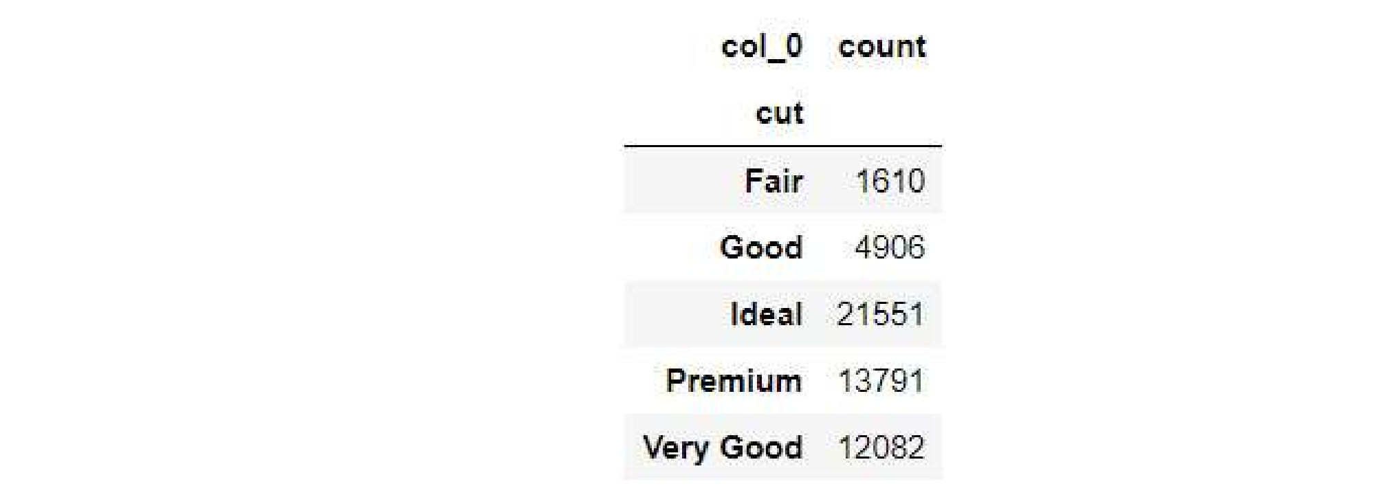
cut_count_table.plot(kind='bar')
The output will be as follows:
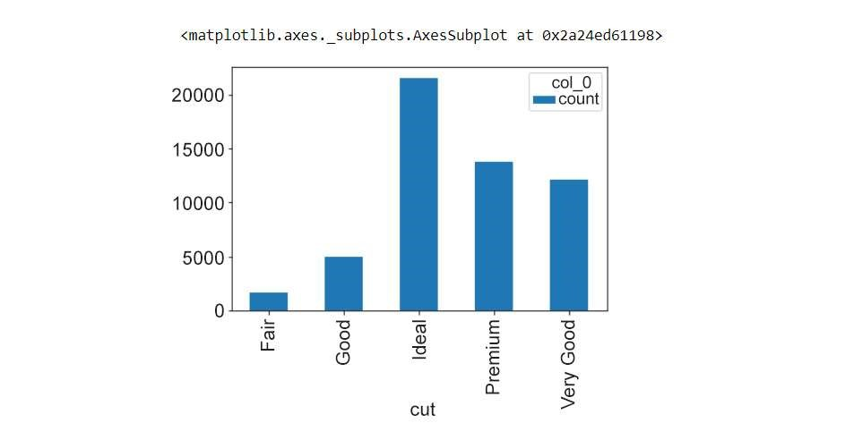
Figure 1.21: Bar plot using a pandas DataFrame
We see that most of the diamonds in the dataset are of the Ideal cut quality, followed by Premium, Very Good, Good, and Fair. Now, let's see how to generate the same plot using seaborn.
- Generate the same bar plot using seaborn:
sns.catplot(data=diamonds_df, x="cut", aspect=1.5, kind="count", color="b") The output will be as follows:
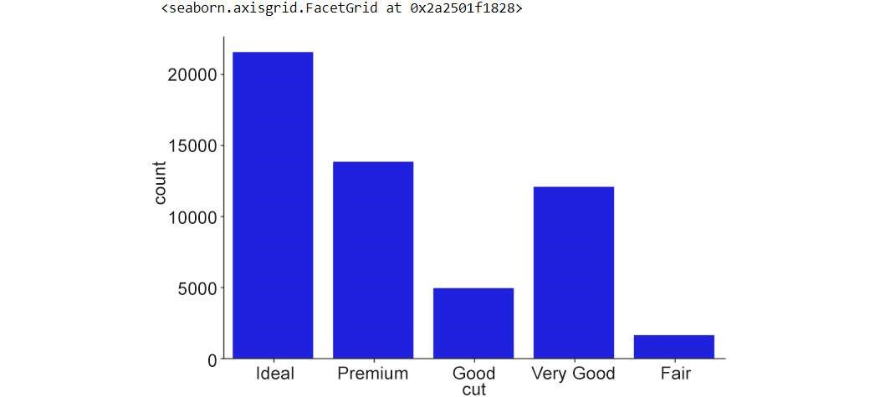
Figure 1.22: Bar plot using seaborn
Notice how the catplot() function does not require us to create the intermediate count table (using pd.crosstab()), and reduces one step in the plotting process.
- Next, here is how we obtain the mean price distribution of different cut qualities using seaborn:
import seaborn as sns
from numpy import median, mean
sns.set(style="whitegrid")
ax = sns.barplot(x="cut", y="price", data=diamonds_df,estimator=mean)
The output will be as follows:
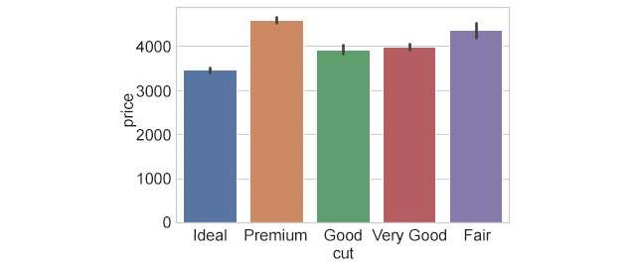
Figure 1.23: Bar plot with the mean price distribution
Here, the black lines (error bars) on the rectangles indicate the uncertainty (or spread of values) around the mean estimate. By default, this value is set to 95% confidence. How do we change it? We use the ci=68 parameter, for instance, to set it to 68%. We can also plot the standard deviation in the prices using ci=sd.
- Reorder the x axis bars using order:
ax = sns.barplot(x="cut", y="price", data=diamonds_df, estimator=mean, ci=68, order=['Ideal','Good','Very Good','Fair','Premium'])
The output will be as follows:
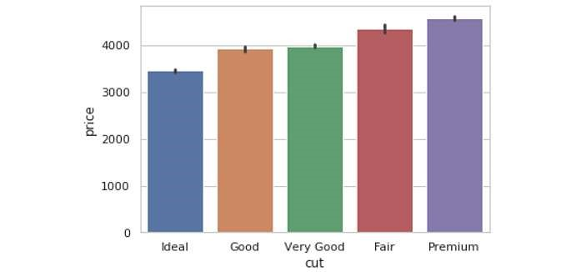
Figure 1.24: Bar plot with proper order
Grouped bar plots can be very useful for visualizing the variation of a particular feature within different groups. Now that you have looked into tweaking the plot parameters in a grouped bar plot, let's see how to generate a bar plot grouped by a specific feature.

Creating Bar Plots Grouped by a Specific Feature
We will use the diamonds dataset to generate the distribution of prices with respect to color for each cut quality. In Creating a Bar Plot and Calculating the Mean Price Distribution, we looked at the price distribution for diamonds of different cut qualities. Now, we would like to look at the variation in each color:
- Use the hue parameter to plot nested groups:
ax = sns.barplot(x="cut", y="price", hue='color', data=diamonds_df)
The output is as follows:
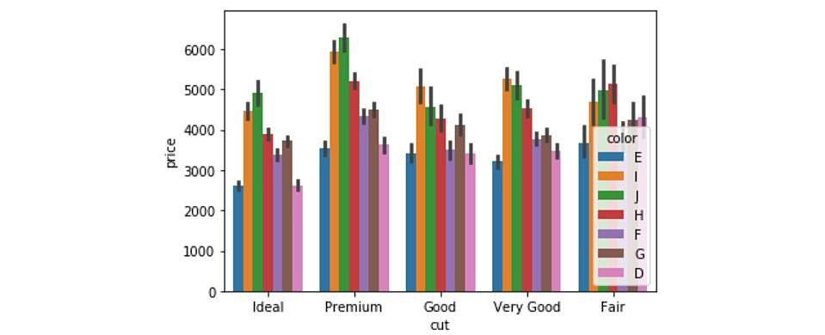
Figure 1.25: Grouped bar plot with legends
Here, we can observe that the price patterns for diamonds of different colours are similar for each cut quality. For instance, for Ideal diamonds, the price distribution of diamonds of different colours is the same as that for Premium, and other diamonds.

Tweaking Plot Parameters
Looking at the last figure in our previous section, we find that the legend is not appropriately placed. We can tweak the plot parameters to adjust the placements of the legends and the axis labels, as well as change the font-size and rotation of the tick labels.

Tweaking the Plot Parameters of a Grouped Bar Plot
Now, we'll tweak the plot parameters, for example, hue, of a grouped bar plot. We'll see how to place legends and axis labels in the right places and also explore the rotation feature:
- Use the hue parameter to plot nested groups:
ax = sns.barplot(x="cut", y="price", hue='color', data=diamonds_df)
The output is as follows:
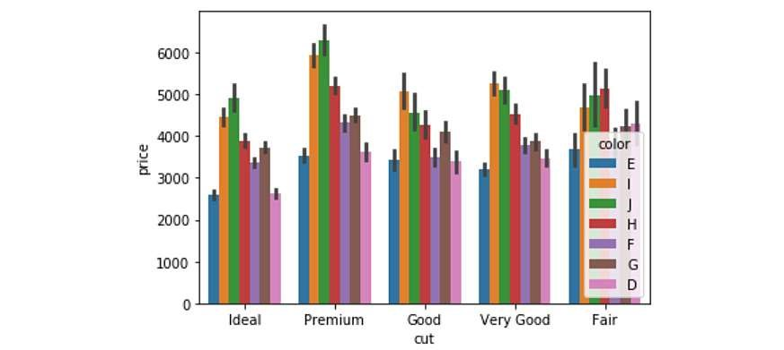
Figure 1.26: Nested bar plot with the hue parameter
- Place the legend appropriately on the bar plot:
ax = sns.barplot(x='cut', y='price', hue='color', data=diamonds_df) ax.legend(loc='upper right',ncol=4)
The output is as follows:
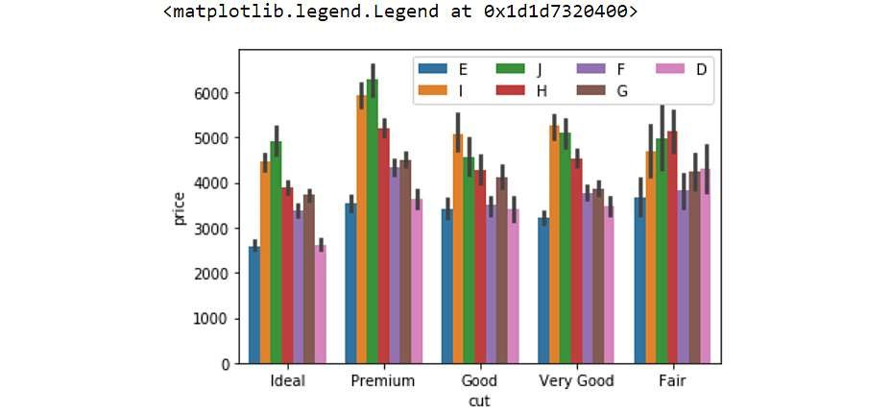
Figure 1.27: Grouped bar plot with legends placed appropriately
In the preceding ax.legend() call, the ncol parameter denotes the number of columns into which values in the legend are to be organized, and the loc parameter specifies the location of the legend and can take any one of eight values (upper left, lower center, and so on).

- To modify the axis labels on the x axis and y axis, input the following code:
ax = sns.barplot(x='cut', y='price', hue='color', data=diamonds_df) ax.legend(loc='upper right', ncol=4) ax.set_xlabel('Cut', fontdict={'fontsize' : 15}) ax.set_ylabel('Price', fontdict={'fontsize' : 15})
The output is as follows:
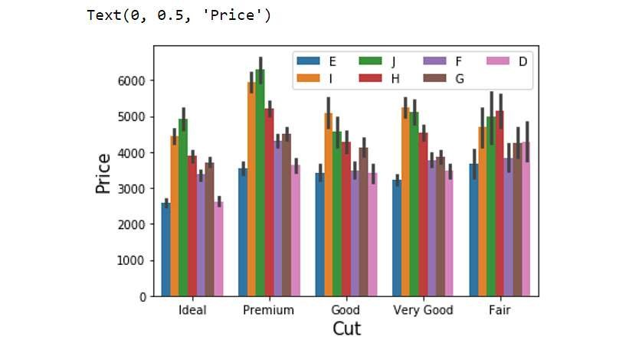
Figure 1.28: Grouped bar plot with modified labels
- Similarly, use this to modify the font-size and rotation of the x axis of the tick labels:
ax = sns.barplot(x='cut', y='price', hue='color', data=diamonds_df) ax.legend(loc='upper right',ncol=4)
# set fontsize and rotation of x-axis tick labels ax.set_xticklabels(ax.get_xticklabels(), fontsize=13, rotation=30)
The output is as follows:
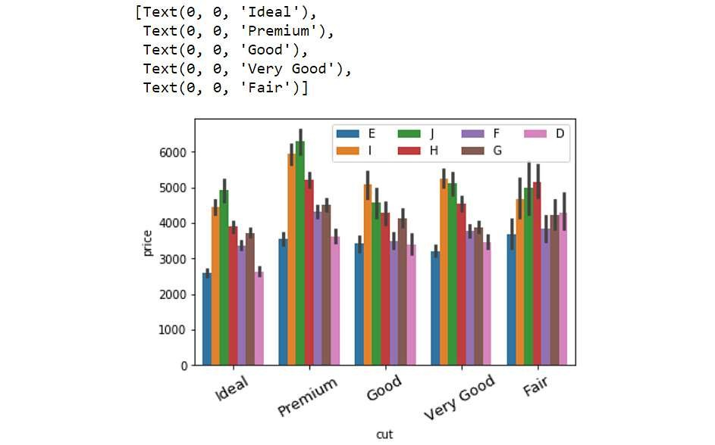
Figure 1.29: Grouped bar plot with the rotation feature of the labels
The rotation feature is particularly useful when the tick labels are long and crowd up together on the x axis.

Annotations
Another useful feature to have in plots is the annotation feature. In the following exercise, we'll make a simple bar plot more informative by adding some annotations.Suppose we want to add more information to the plot about ideally cut diamonds.

Annotating a Bar Plot
We will annotate a bar plot, generated using the catplot function of seaborn, using a note right above the plot. Let's see how:
- Generate a bar plot using catplot function of the seaborn library:
ax = sns.catplot("cut", data=diamonds_df, aspect=1.5, kind="count", color="b") The output is as follows:
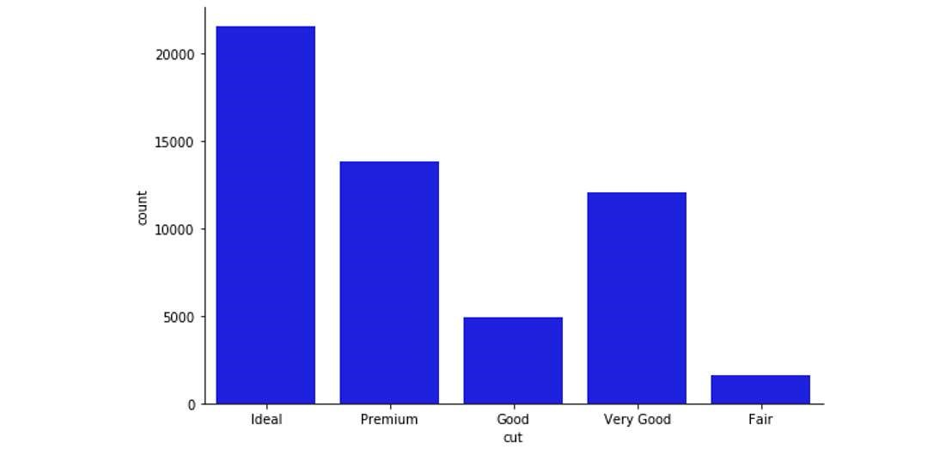
Figure 1.30: Bar plot with seaborn's catplot function
- Annotate the column belonging to the Ideal category:
# get records in the DataFrame corresponding to ideal cut
ideal_group = diamonds_df.loc[diamonds_df['cut']=='Ideal']
- Find the location of the x coordinate where the annotation has to be placed: # get the location of x coordinate where the annotation has to be placed
x = ideal_group.index.tolist()[0]
- Find the location of the y coordinate where the annotation has to be placed:
# get the location of y coordinate where the annotation has to be placed
y = len(ideal_group)
- Print the location of the x and y co-ordinates:
print(x)
print(y)
The output is:
0
21551
- Annotate the plot with a note:
# annotate the plot with any note or extra information
sns.catplot("cut", data=diamonds_df, aspect=1.5, kind="count", color="b")
plt.annotate('excellent polish and symmetry ratings;\nreflects almost all the light that enters it', xy=(x,y), xytext=(x+0.3, y+2000), arrowprops=dict(facecolor='red'))
The output is as follows:
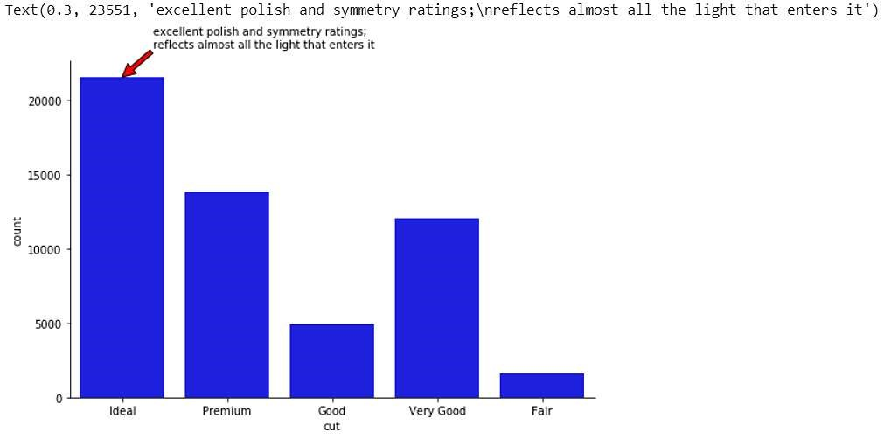
Figure 1.31: Annotated bar plot

Now, there seem to be a lot of parameters in the annotate function, but worry not! Matplotlib's https://matplotlib.org/stable/api/_as_gen/matplotlib.pyplot.annotate.html official documentation covers all the details. For instance, the xy parameter denotes the point (x,y) on the figure to annotate. xytext denotes the position (x,y) to place the text at. If None, it defaults to xy. Note that we added an offset of .3 for x and 2000 for y (since y is close to 20,000) for the sake of readability of the text. The colour of the arrow is specified using the arrowprops parameter in the annotate function.
There are several other bells and whistles associated with visualization libraries in Python, some of which we will see as we progress in the book. At this stage, we will go through a chapter activity to revise the concepts in this chapter.
So far, we have seen how to generate two simple plots using seaborn and pandas—histograms and bar plots:
- Histograms: Histograms are useful for understanding the statistical distribution of a
numerical feature in a given dataset. They can be generated using the hist() function in pandas and distplot() in seaborn.
- Bar plots: Bar plots are useful for gaining insight into the values taken by a categorical feature in a given dataset. They can be generated using the plot(kind='bar') function in pandas and the catplot(kind='count'), and barplot() functions in seaborn.
With the help of various considerations arising in the process of plotting these two types of visualizations, we presented some basic concepts in data visualization:
- Formatting legends to present labels for different elements in the plot with loc and other parameters in the legend function
- Changing the properties of tick labels, such as font-size, and rotation, with parameters in the set_xticklabels() and set_yticklabels() functions
- Adding annotations for additional information with the annotate() function

Summary
In this tutorial, we covered the basics of handling pandas DataFrames to format them as inputs for different visualization functions in libraries such as pandas , seaborn and more, and we covered some essential concepts in generating and modifying plots to create pleasing figures.
The pandas library contains functions such as read_csv(), read_excel(), and read_json() to read structured text data files. Functions such as describe() and info() are useful to get information on the summary statistics and memory usage of the features in a DataFrame. Other important operations on pandas DataFrames include subletting based on user-specified conditions/constraints, adding new columns to a DataFrame, transforming existing columns with built-in Python functions as well as user-defined functions, deleting specific columns in a DataFrame, and writing a modified DataFrame to a file on the local system.
Once equipped with knowledge of these common operations on pandas DataFrames, we went over the basics of visualization and learned how to refine the visual appeal of the plots. We illustrated these concepts with the plotting of histograms and bar plots. Specifically, we learned about different ways of presenting labels and legends, changing the properties of tick labels, and adding annotations.

